Chapter 18, Solution 5.

Obtain the Fourier transform of the signal shown in Fig. 18.30.

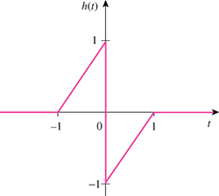

Figure 18.30
For Prob. 18.5.

Solution

t

1

–2δ(t)

–1

h’(t)

0

1

t

1

–2δ’(t)

–1

h”(t)

0

1

–δ(t–1)

δ(t+1)

H(ω) =

